Decagonal Prismoid

Definition
# Source: AI Source: Provided by: [Data Path: Persons Table -> ID Column: 1, Name_En Column: Motasem Essam] -> From: [ChatGPT] on [7/25/2026]
A Decagonal Prismoid is a polyhedron with two parallel decagonal bases, each having ten sides and ten vertices, connected by ten quadrilateral lateral faces.
The upper and lower decagonal bases may differ in size, shape, or orientation. The connecting edges must be arranged so that all ten lateral quadrilaterals are planar.
A decagonal prismoid has 12 faces, 30 edges, and 20 vertices.

Geometric Structure
# Source: AI Source: Provided by: [Data Path: Persons Table -> ID Column: 1, Name_En Column: Motasem Essam] -> From: [ChatGPT] on [7/25/2026]
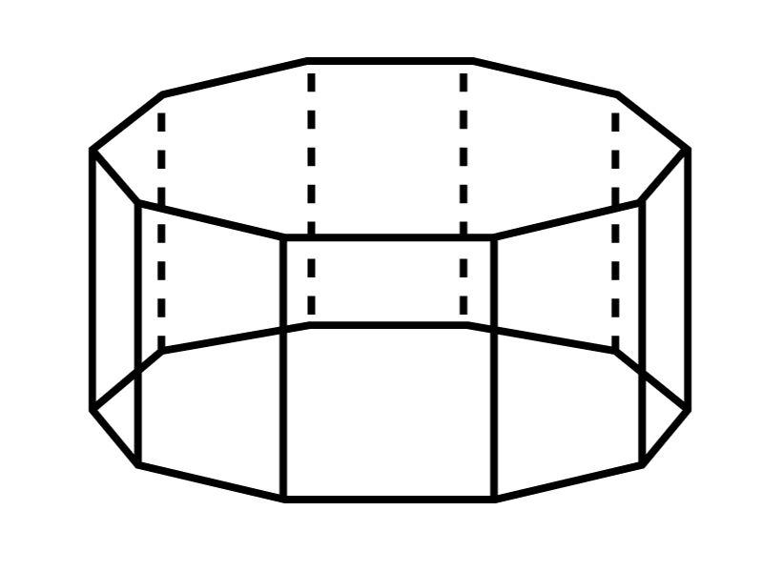
Its main elements are:
- Lower Decagonal Base: The bottom ten-sided polygon.
- Upper Decagonal Base: The top ten-sided polygon, parallel to the lower base.
- Lateral Faces: Ten quadrilateral faces connecting corresponding sides of the bases.
- Lateral Edges: Ten edges connecting corresponding vertices of the two bases.
- Vertices: Twenty vertices in total.
- Altitude: The perpendicular distance between the two base planes.
- Midsection: A cross-section parallel to the bases, halfway between them.

Face Composition
# Source: AI Source: Provided by: [Data Path: Persons Table -> ID Column: 1, Name_En Column: Motasem Essam] -> From: [ChatGPT] on [7/25/2026]
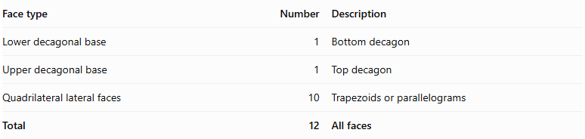
Face type | Number | Description
Lower decagonal base | 1 | Bottom decagon
Upper decagonal base | 1 | Top decagon
Quadrilateral lateral faces | 10 | Trapezoids or parallelograms
Total | 12 | All faces

Mathematical Properties
# Source: AI Source: Provided by: [Data Path: Persons Table -> ID Column: 1, Name_En Column: Motasem Essam] -> From: [ChatGPT] on [7/25/2026]
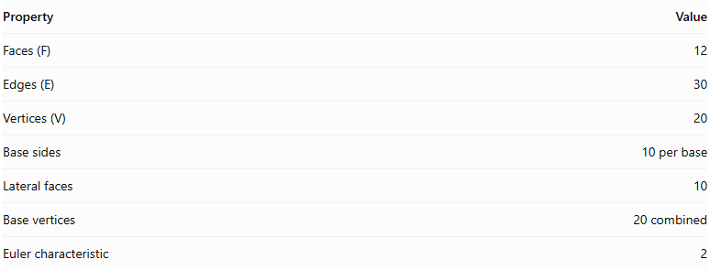
Property | Value
Faces (F) | 12
Edges (E) | 30
Vertices (V) | 20
Base sides | 10 per base
Lateral faces | 10
Base vertices | 20 combined
Euler characteristic | 2
Euler's Formula:
$$V-E+F=2$$
$$20-30+12=2$$
Volume — Prismoidal Formula:
$$V=\frac{h}{6}(A_{1}+4A_{m}+A_{2})$$
Where:
- $A_{1}$ = Area of the lower decagonal base.
- $A_{2}$ = Area of the upper decagonal base.
- $A_{m}$ = Area of the midsection parallel to the bases.
- $h$ = Perpendicular distance between the bases.

Area of a Regular Decagon:
$$A=\frac{5s^{2}}{2tan({18}^{∘})}$$
Where $s$ is the side length of the regular decagon.

Geometric Characteristics
# Source: AI Source: Provided by: [Data Path: Persons Table -> ID Column: 1, Name_En Column: Motasem Essam] -> From: [ChatGPT] on [7/25/2026]
- It has two parallel decagonal bases.
- Each base has ten sides and ten vertices.
- It has ten quadrilateral lateral faces.
- Its lateral faces may be trapezoids or parallelograms.
- The two bases do not have to be congruent or similar.
- Its altitude is measured perpendicular to the base planes.
- Its midsection is parallel to both bases.
- It has 20 vertices, 30 edges, and 12 faces.

Types of Decagonal Prismoids
# Source: AI Source: Provided by: [Data Path: Persons Table -> ID Column: 1, Name_En Column: Motasem Essam] -> From: [ChatGPT] on [7/25/2026]
- Regular Decagonal Prismoid: Both bases are regular decagons.
- Irregular Decagonal Prismoid: At least one base is an irregular decagon.
- Similar-Bases Decagonal Prismoid: The two decagonal bases are similar polygons.
- Non-Similar-Bases Decagonal Prismoid: The two decagonal bases are not similar polygons.
These are descriptive subdivisions for classification rather than universally standardized solid names.

Constructing a Decagonal Prismoid

Geometric Instruments
# Source: AI Source: Provided by: [Data Path: Persons Table -> ID Column: 1, Name_En Column: Motasem Essam] -> From: [ChatGPT] on [7/25/2026]
The following instruments can be used to construct a decagonal prismoid using traditional geometric drawing methods:
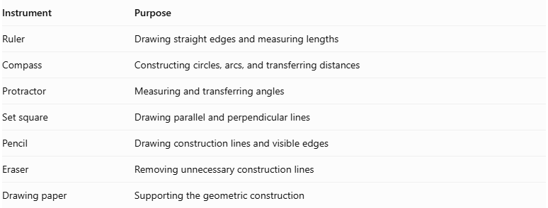
Instrument | Purpose
Ruler | Drawing straight edges and measuring lengths
Compass | Constructing circles, arcs, and transferring distances
Protractor | Measuring and transferring angles
Set square | Drawing parallel and perpendicular lines
Pencil | Drawing construction lines and visible edges
Eraser | Removing unnecessary construction lines
Drawing paper | Supporting the geometric construction
Important note about the regular decagon: A regular decagon can be constructed exactly using an unmarked straightedge and compass. Its central angle is ${36}^{°}$, and its interior angle is ${144}^{°}$.

Instrument-Based Construction Procedures

Method 1: Constructing from Two Parallel Decagonal Bases
# Source: AI Source: Provided by: [Data Path: Persons Table -> ID Column: 1, Name_En Column: Motasem Essam] -> From: [ChatGPT] on [7/25/2026]
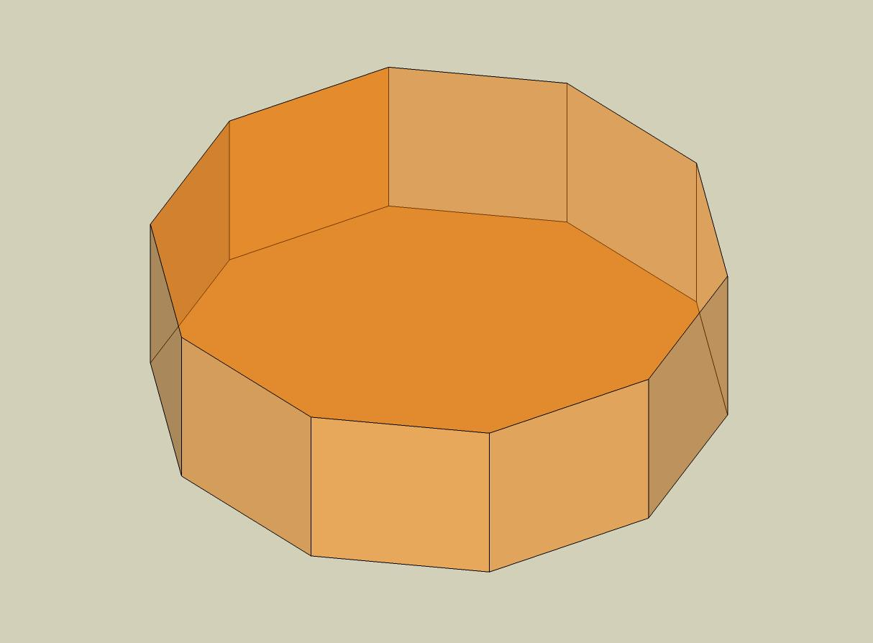
- Draw the lower decagonal base $ABCDEFGHIJ$ using a ruler and compass.
- If constructing a regular decagon, divide a circle into ten equal central angles of ${36}^{°}$.
- Establish the required perpendicular height above the lower base.
- Draw the upper decagonal base $A'B'C'D'E'F'G'H'I'J'$ in a plane parallel to the lower base.
- Choose the dimensions and positions of the upper decagon so that the corresponding connecting edges produce planar lateral quadrilaterals.
- Connect $A$ to $A'$.
- Connect $B$ to $B'$.
- Connect $C$ to $C'$.
- Connect $D$ to $D'$.
- Connect $E$ to $E'$.
- Connect $F$ to $F'$.
- Connect $G$ to $G'$.
- Connect $H$ to $H'$.
- Connect $I$ to $I'$.
- Connect $J$ to $J'$.
- Join the corresponding base edges to complete the ten lateral quadrilaterals.
- Erase unnecessary construction lines and distinguish visible edges from hidden edges.

Method 2: Constructing from a Decagonal Base and Its Parallel Upper Section
# Source: AI Source: Provided by: [Data Path: Persons Table -> ID Column: 1, Name_En Column: Motasem Essam] -> From: [ChatGPT] on [7/25/2026]
- Construct a decagon $ABCDEFGHIJ$ as the lower base.
- Draw a parallel upper construction plane at the required perpendicular height.
- Construct a second decagon $A'B'C'D'E'F'G'H'I'J'$ on the upper plane.
- Determine the corresponding positions of the ten upper vertices.
- Check that each pair of corresponding base edges and connecting lateral edges defines a planar quadrilateral.
- Connect the corresponding vertices.
- Complete all ten lateral faces.
- Verify that the upper and lower bases are parallel.
- Finalize the drawing by removing auxiliary lines and marking visible and hidden edges.

Method 3: Constructing Through Parallel Cross-Sections
# Source: AI Source: Provided by: [Data Path: Persons Table -> ID Column: 1, Name_En Column: Motasem Essam] -> From: [ChatGPT] on [7/25/2026]
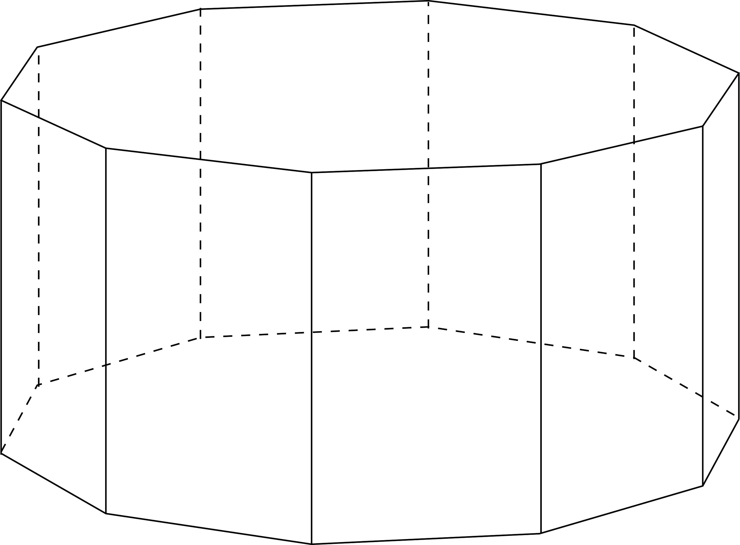
- Draw the lower decagonal base $ABCDEFGHIJ$.
- Establish the perpendicular height of the solid.
- Mark the halfway level between the two bases.
- Construct a middle decagonal cross-section $A_{m}B_{m}C_{m}D_{m}E_{m}F_{m}G_{m}H_{m}I_{m}J_{m}$, parallel to the bases.
- Construct the upper decagonal base $A'B'C'D'E'F'G'H'I'J'$.
- Connect the corresponding vertices of the lower, middle, and upper decagons.
- Ensure that the resulting lateral faces are planar quadrilaterals.
- Complete the visible and hidden edges.
The middle cross-section is used to calculate the volume using the prismoidal formula. Its area must be determined from the actual geometry.

Related Geometric Solids
# Source: AI Source: Provided by: [Data Path: Persons Table -> ID Column: 1, Name_En Column: Motasem Essam] -> From: [ChatGPT] on [7/25/2026]
- Decagonal Prism
- Decagonal Pyramidal Frustum
- Decagonal Prismatoid
- Nonagonal Prismoid
- Undecagonal Prismoid

Main Classification
# Source: AI Source: Provided by: [Data Path: Persons Table -> ID Column: 1, Name_En Column: Motasem Essam] -> From: [ChatGPT] on [7/25/2026]
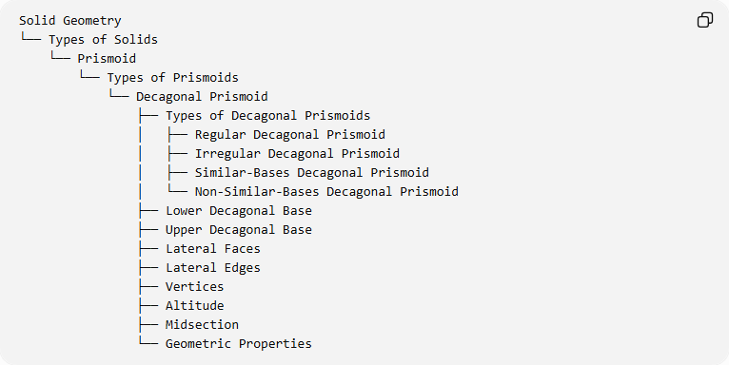
Solid Geometry
└── Types of Solids
└── Prismoid
└── Types of Prismoids
└── Decagonal Prismoid
├── Types of Decagonal Prismoids
│ ├── Regular Decagonal Prismoid
│ ├── Irregular Decagonal Prismoid
│ ├── Similar-Bases Decagonal Prismoid
│ └── Non-Similar-Bases Decagonal Prismoid
├── Lower Decagonal Base
├── Upper Decagonal Base
├── Lateral Faces
├── Lateral Edges
├── Vertices
├── Altitude
├── Midsection
└── Geometric Properties

Key Points
# Source: AI Source: Provided by: [Data Path: Persons Table -> ID Column: 1, Name_En Column: Motasem Essam] -> From: [ChatGPT] on [7/25/2026]
- A decagonal prismoid has two parallel decagonal bases.
- It contains 12 faces, 30 edges, and 20 vertices.
- It has ten quadrilateral lateral faces.
- Its volume can be calculated using the prismoidal formula.
- It belongs to the family of prismoids.

Conclusion
# Source: AI Source: Provided by: [Data Path: Persons Table -> ID Column: 1, Name_En Column: Motasem Essam] -> From: [ChatGPT] on [7/25/2026]
The Decagonal Prismoid is a polyhedron formed by two parallel ten-sided bases connected by ten quadrilateral lateral faces. Its structure follows the general properties of prismoids, with 12 faces, 30 edges, and 20 vertices.

